**Documentation for Multi-Monitor Extension**

**Steps to install extension in your browser :**

**[Developer Mode]**

1. On Chrome or Microsoft Edge, tap on three dots in the top right corner.
2. Click on Extensions > Manage Extension.
3. Turn on developer mode. As soon as you turn it on it expands the features to upload extension from your system.

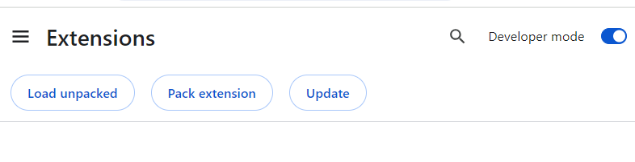

1. Click on Load unpacked and select the folder that contains your extension, the extension will be uploaded.

**[Production Mode]**

**After the extension is published, the user can directly access it from chrome web store.**

1. On Chrome or Microsoft Edge, tap on three dots in the top right corner.
2. Click on Extensions > Visit Chrome Web Store.
3. Search for the name of the extension and Add it to Chrome or Microsoft Edge

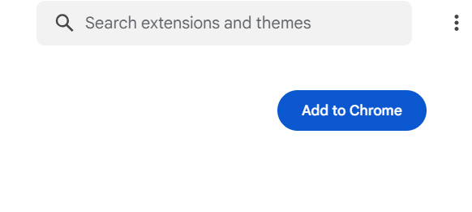

1. **The extension will be added to** Chrome or Microsoft Edge.

**Changes require in website :**

* Please add **action-secondary-screen="true"** to your anchor tag where you want your screen setting functionality to be applicable. This will allow screen setting extension to detect the tag on which click, screen setting function to be applicable

Example:

<a href=" https://www.google.com/" action-secondary-screen="true" target="_blank"> Navigate to another page</a>

**Steps to use extension in your browser :**

**The Extension is now added to your browser click on the highlighted icon**

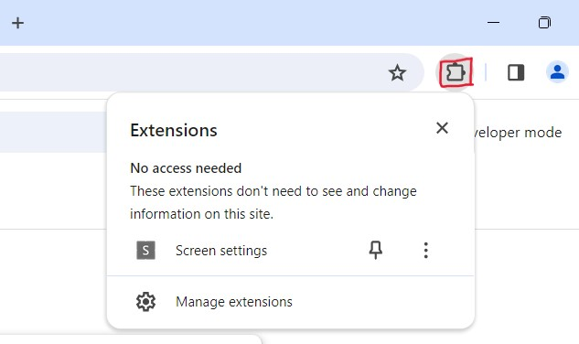

1. Now click on Screen Settings extension. It will open a popup displaying the monitors that are connected.

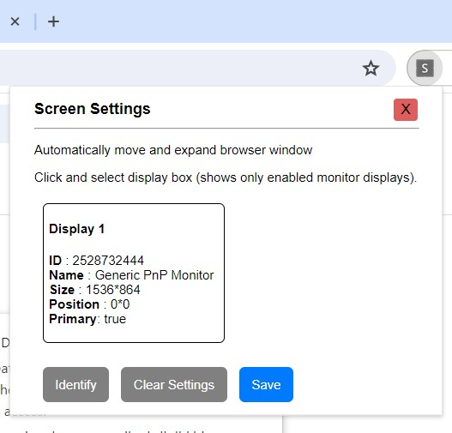

1. To use the extension, and choose to display the result on Screen 1 or Screen 2 or in both Screen 1 and Screen 2 (expanded format), you need to add an attribute to your button which opens the result in the screens as selected in the extension.

The attribute you need to add in your button is:

**action-secondary-screen="true"**

Example:

<a href=" https://www.google.com/" action-secondary-screen="true" target="_blank"> Navigate to another page</a>

1. By clicking on **“Navigate to another page”** it will show your url on eitheron Screen 1 or Screen 2 or in both Screen 1 and Screen 2 (expanded format) as selected by the user.

**Extension Workflow :**

* Choosing the Display 1, and click on **Save** button, it will save your Display 1 and your result will be displayed on monitor 1.

It displays the message: “Display settings saved successfully.”

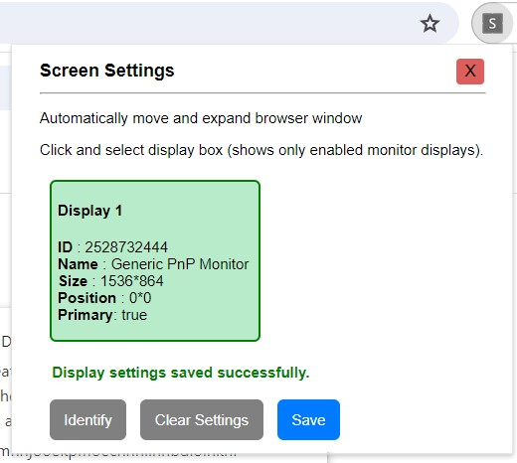

* Click on the **Clear Settings** button to clear all the selected displays.

It displays the message: “Display settings cleared successfully.”

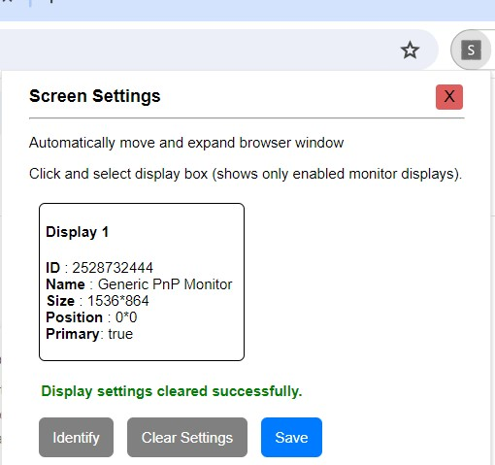

* Click on the **Identify** button to open a popup about display identification.

